ANTI-THEFT SYSTEM

OBJECTIVE

The purpose of this lab is to get the understanding of finite state machine and implementing its complex application using System Verilog programming. Design a digital system (Car Alarm) with sequential circuit (FSM) based on a set of specifications

INTRODUCTION

Porsche Anti-Theft System
An entrepreneur bought a new Porsche after the success of her first product. Though the car has a built in anti-theft system, she is concerned since this is a standard factory unit and many people know how to disable it. So, she's looking for someone to design and build a system with some hidden security features only you two will know about! Your job is to create a working prototype.

In this lab you will implement an anti-theft system that uses several interacting FSMs to process sensor inputs and generate the appropriate actuator control signals.

THEORY

Description of Anti-Theft System
Since your client is completely focused on her start-up, she wants an anti-theft system that's highly automated. The system is armed automatically after she turns off the ignition, exits the car (i.e., the driver's door has opened and closed) and T_ARM_DELAY has passed. If there is a passenger and both the driver's door and passenger's doors are open, the system arms itself after all the doors have been closed and T_ARM_DELAY has passed; that delay is restarted if a door is opened and reclosed before the alarm has been armed.

Once the system has been armed, opening the driver's door the system begins a countdown. If the ignition is not turned on within the countdown interval (T_DRIVER_DELAY), the siren sounds. The siren remains on as long as the door is open and for some additional interval (T_ALARM_ON) after the door closes, at which time the system resets to the armed but silent state. If the ignition is turned on within the countdown interval, the system is disarmed.

Always a paragon of politeness, your client opens the passenger door first if she's transporting a guest. When the passenger door is opened first, a separate, presumably longer, delay (T_PASSENGER_DELAY) is used for the countdown interval, giving her extra time to walk around to the driver's door and insert the key in the ignition to disarm the system.

There is a status indicator LED on the dash. It blinks with a two-second period when the system is armed. It is constantly illuminated either the system is in the countdown waiting for the ignition to turn on or if the siren is on. The LED is off is the system is

The diagram below lists all the sensors (inputs) and actuators (outputs) connected to the system.

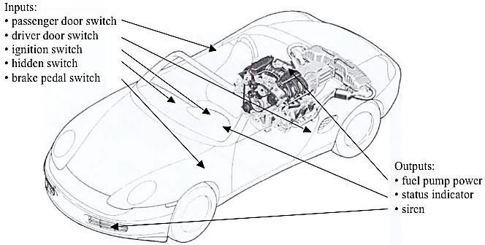

Fig 1: System Diagram showing sensors (inputs) and actuators (outputs)
The system timings are based on four parameters (in seconds): the delay between exiting the car and the arming of the alarm (T_ARM_DELAY), the length of the countdown before the alarm sounds after opening the driver's door (T_DRIVER_DELAY) or passenger door (T_PASSENGER_DELAY), and the length of time the siren sounds (T_ALARM_ON). The default value for each parameter is listed in the table below, but each may be set to other values using the Time_Parameter_Selector, Time_Value, and Reprogram signals. Time_Parameter_Selector switches specify the parameter number of the parameter to be changed. Time_Value switches are a 4-bit value representing the value to be programmed -- a value in seconds between 0 and 15. Pushing the Reprogram button tells the system to set the currently selected parameter to Time_Value. Note that your system should behave correctly even if one or more of the parameters is set to 0.

Default Timing Parameters

Interval  Name | Symbol | Parameter Number | Default Time(sec) | Time Value
Arming Delay | T_ARM_DELAY | 00 | 6 | 0110
Countdown, driver’s door | T_DRIVER_DELAY | 01 | 8 | 1000
Countdown, passenger’s door | T_PASSENGER_DELAY | 10 | 15 | 1111
Siren ON time | T_ALARM_ON | 11 | 10 | 1010
Table 1: Required timing parameters.

Block Description/Implementation
The following diagram illustrates a possible organization of your design into modules:

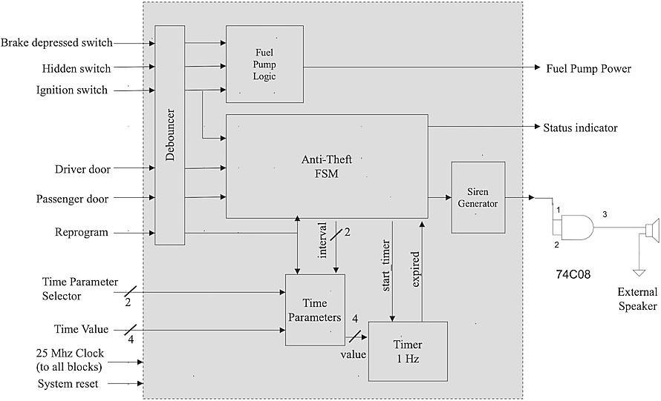
Fig 2: Block diagram of Anti-Theft System

FSM State Descriptions

1. ARMED State
This is the default state of the system and the state entered after reset.

Function
The alarm system is fully active and monitoring the doors for unauthorized access.

Inputs Behavior
- If Ignition_Switch = 1, the system transitions to the DISARMED state.
- If Driver_Door opens, the driver delay timer starts and the system transitions to TRIGGERED state.
- If Passenger_Door opens, the passenger delay timer starts and the system transitions to TRIGGERED state.

Outputs
- Siren_Enable = 0
- Status_Indicator_Led = Blink_Signal (LED blinks indicating the system is armed)
- Start_Timer is asserted when a door opens.
- Interval_Signal selects the appropriate countdown delay.

2. ARMED_DELAY State
This state is entered when the driver exits the vehicle and the system is waiting before arming the alarm.

Function
The system waits for the arming delay timer to expire before returning to the ARMED state.

Inputs Behavior
- If Ignition_Switch = 1, the system moves to DISARMED.
- If Expired_Signal = 1, the system transitions to ARMED.
- Otherwise the FSM remains in this state.

Outputs
- Siren_Enable = 0
- Status_Indicator_Led = 0

3. TRIGGERED State
This state occurs when the system detects that a door has opened while the alarm system is armed.

Function
The system begins a countdown allowing the driver time to turn on the ignition before the alarm is triggered.

Inputs Behavior
- If Ignition_Switch = 1, the system moves to DISARMED.
- If Expired_Signal = 1, the system transitions to SOUND_ALARM.
- Otherwise the system stays in this state.

Outputs
- Siren_Enable = 0
- Status_Indicator_Led = 1 (LED remains ON indicating a warning state)

4. SOUND_ALARM State
This state occurs when the countdown expires without the ignition being turned on.

Function
The alarm siren is activated indicating a potential theft attempt.

Inputs Behavior
- If Ignition_Switch = 1, the system transitions to DISARMED.
- If both doors close, the system starts the alarm duration timer and transitions to ALARM_WAIT_DOORS.

Outputs
- Siren_Enable = 1
- Status_Indicator_Led = 1

5. ALARM_WAIT_DOORS State
This state keeps the alarm active for a specified duration after the doors have closed.

Function
Ensures the siren remains active for the defined alarm time before resetting the system.

Inputs Behavior
- If Ignition_Switch = 1, the system transitions to DISARMED.
- If Expired_Signal = 1, the system transitions back to ARMED.

Outputs
- Siren_Enable = 1
- Status_Indicator_Led = 1

6. DISARMED State
This state indicates that the alarm system is inactive and the vehicle can be used normally.

Function
The system remains inactive while the ignition is ON.

Inputs Behavior
- When Ignition_Switch = 0 and Driver_Door opens, the system starts the arming delay timer.
- The FSM then transitions to ARMED_DELAY.

Outputs
- Siren_Enable = 0
- Status_Indicator_Led = 0

SUMMARY of FSM Operation
The FSM continuously monitors the vehicle sensors and manages the alarm system through several states including Armed, Triggered, Alarm, and Disarmed modes. Timer signals and door events control transitions between states. The FSM ensures that unauthorized access triggers the alarm while allowing legitimate users to disarm the system by turning on the ignition within the specified delay period.

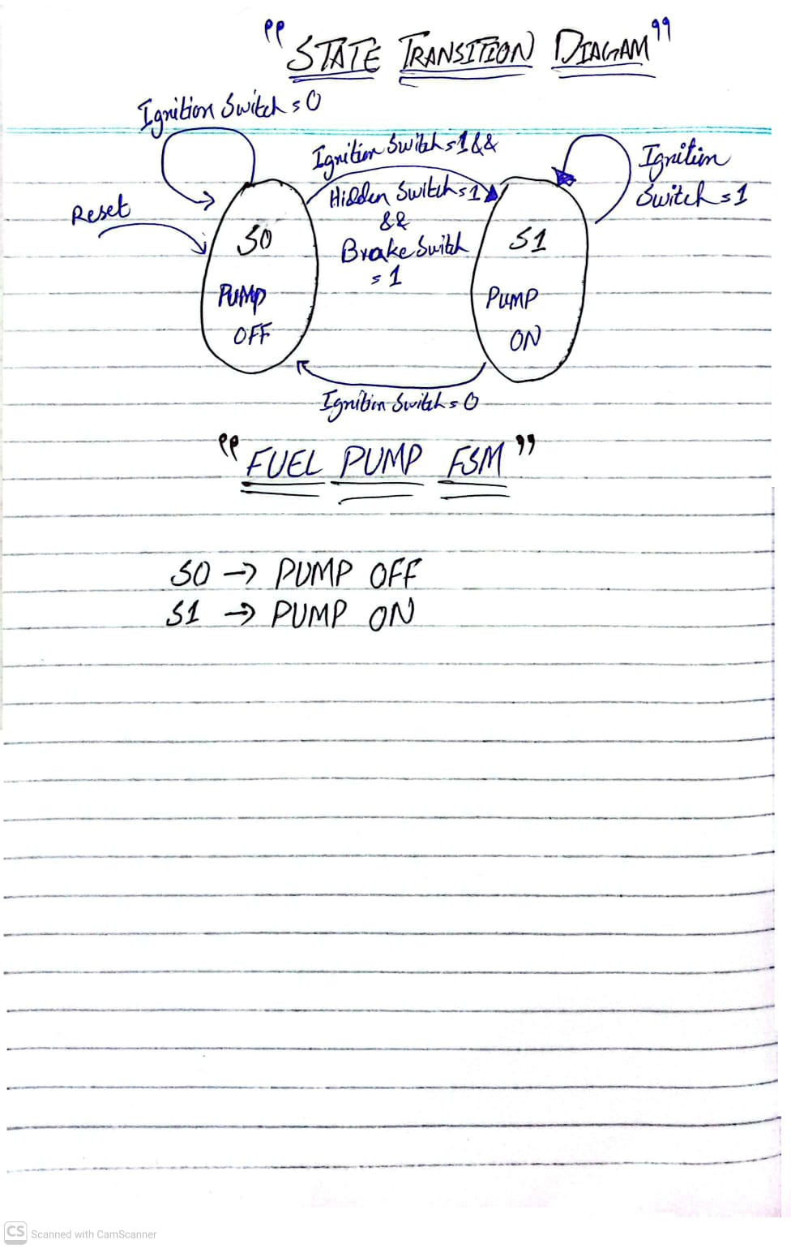
FUEL PUMP STATE DIAGRAM:

ANTI THEFT FSM STATE DIAGRAM:

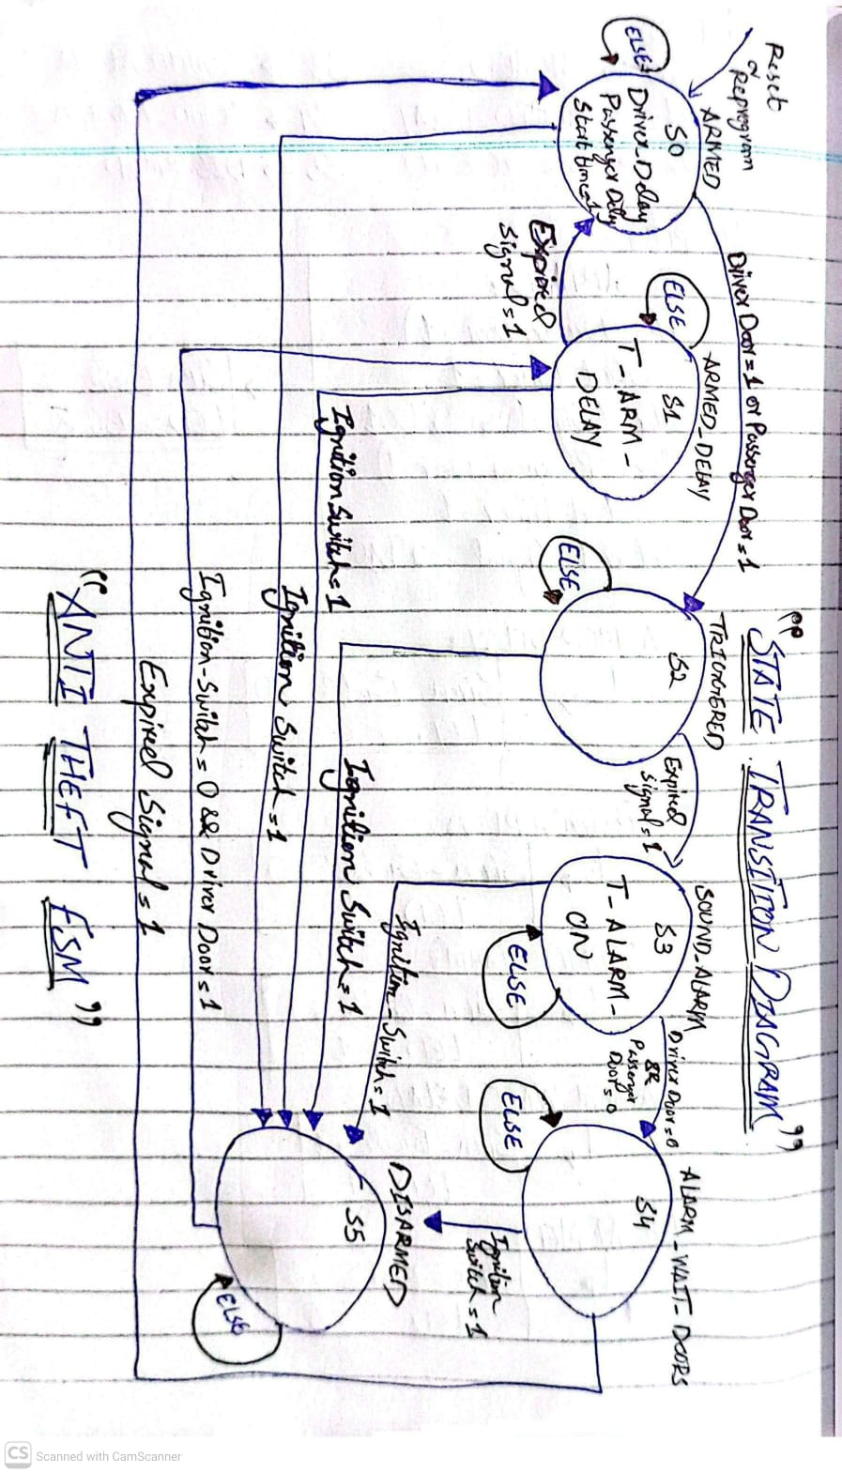

UEL PUMP STATE DIAGRAM:

STATES AND OUTPUT SIGNALS

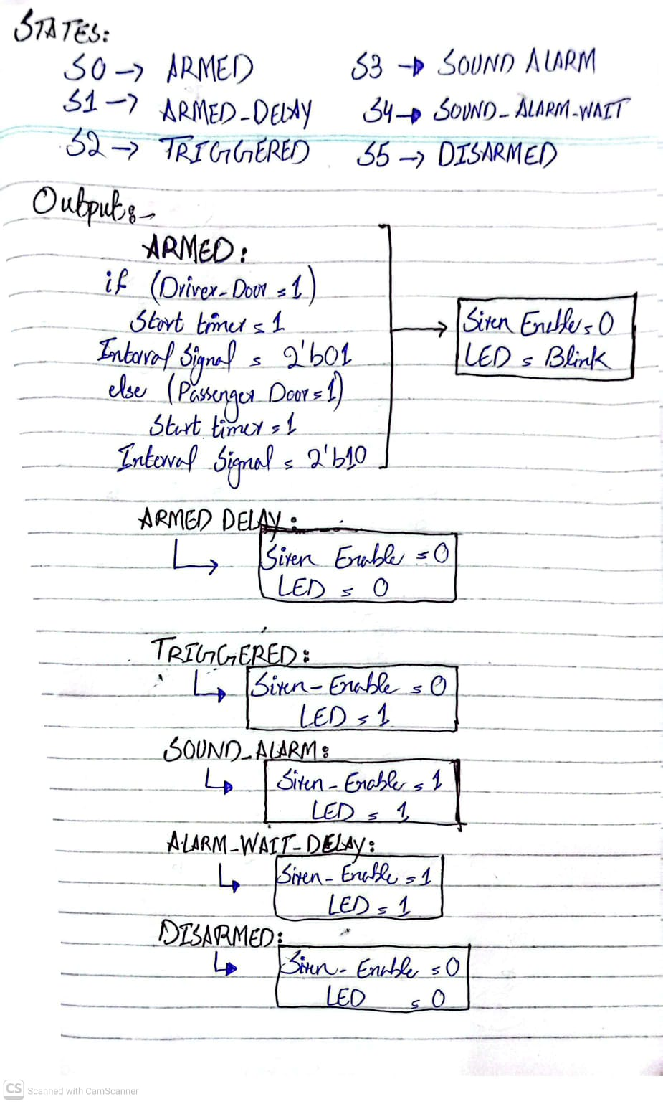

TOP MODULE FSM CODE

INPUTS AND OUTPUTS
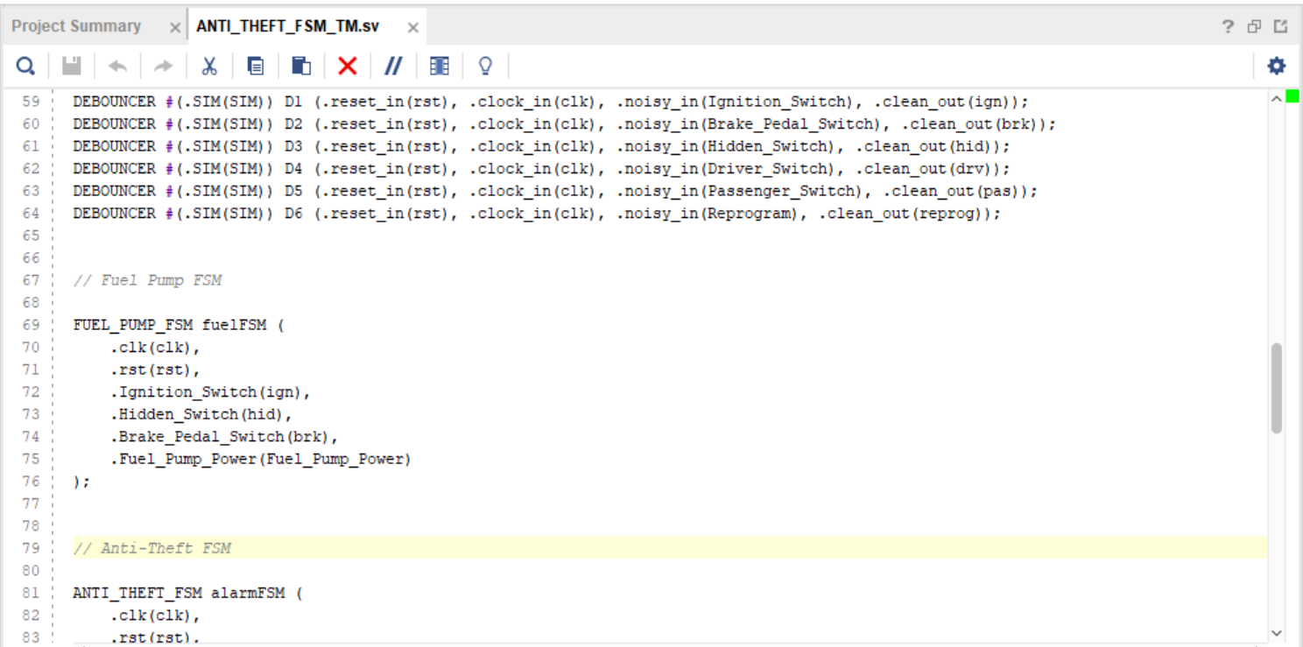
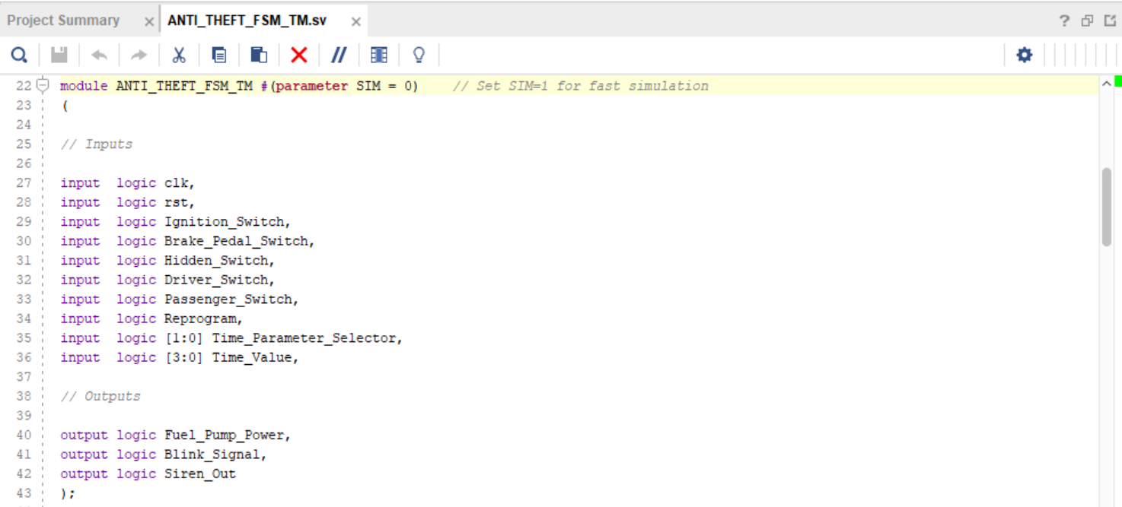

DEBOUNCER AND PUMP FUEL FSM

ANTI THEFT FSM AND TIME PARAMETERS

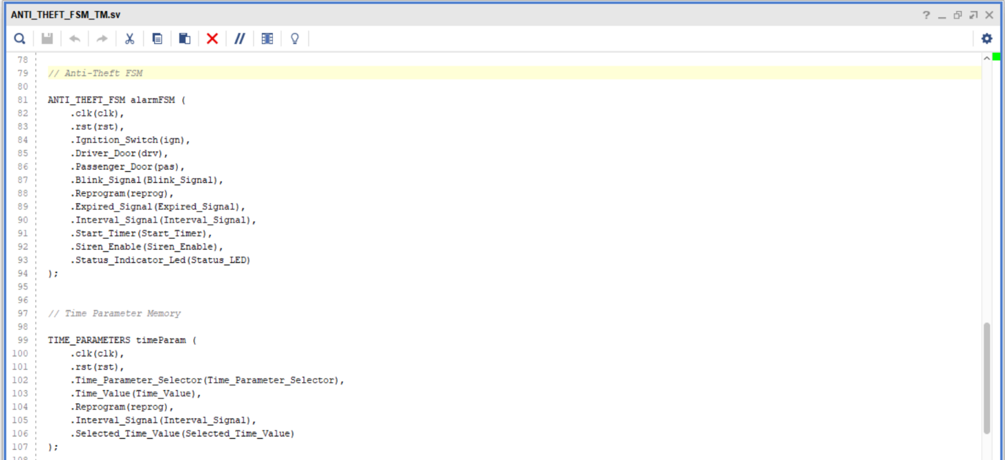

SIREN GENERATOR AND TIMER
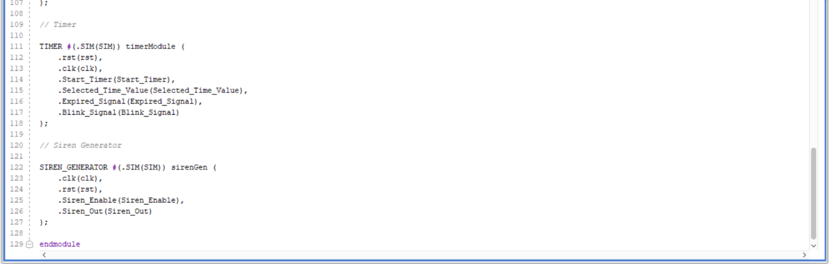

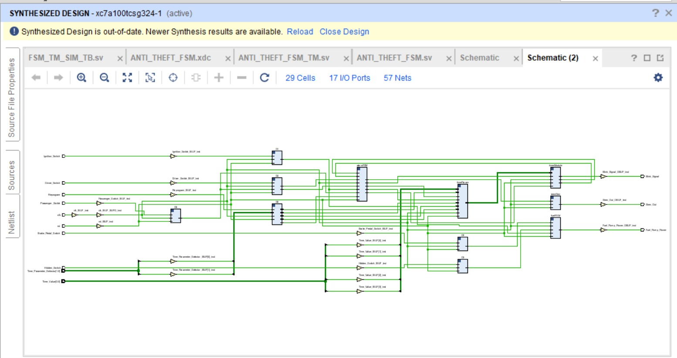

SYNTHESIZED DESIGN
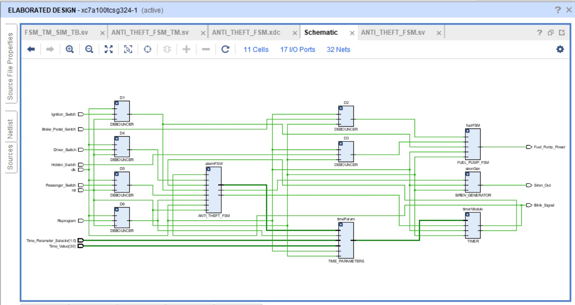
ELABORATED DESIGN

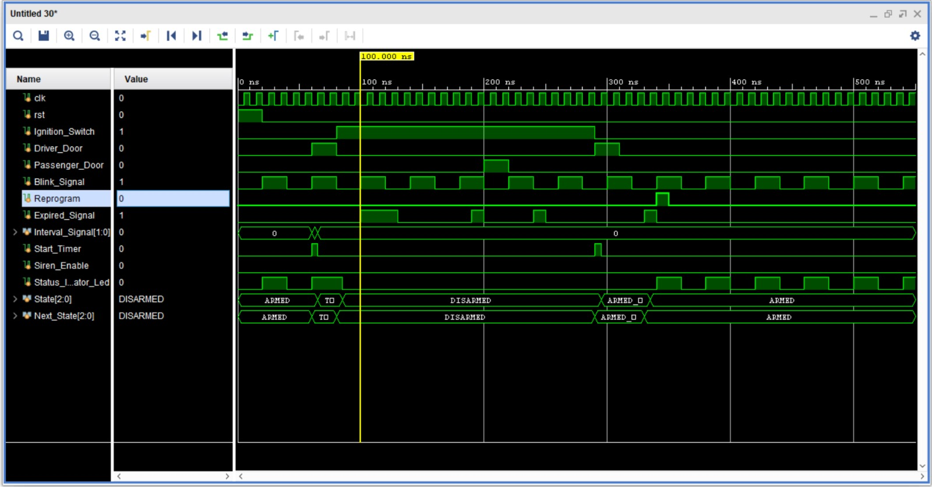
ANTI THEFT FSM RESULTS

ANTI THEFT FSM

- ARMED
- TRIGGERED
- DISARMED

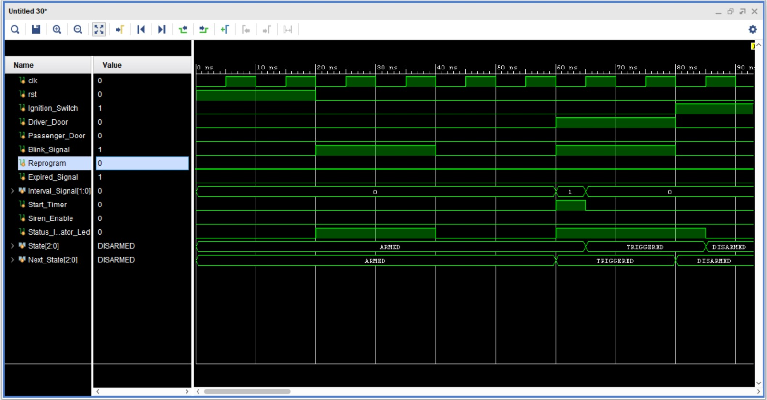

- ARMED DELAY
- ARMED

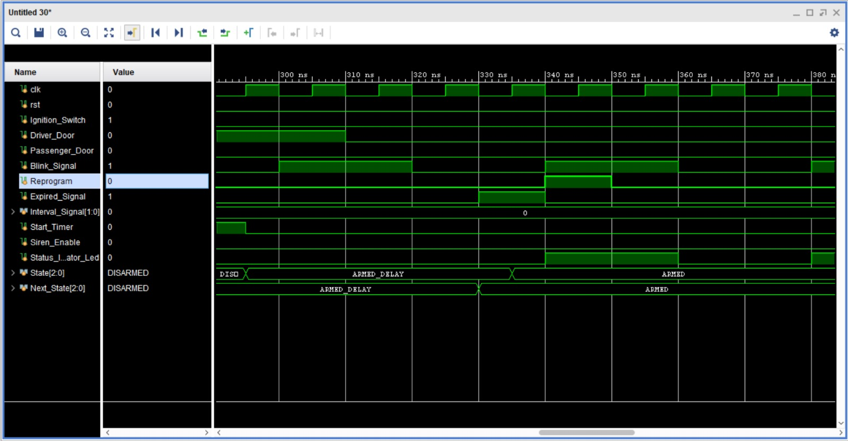

- SOUND ALARM
- ALARM_WAIT_DOORS

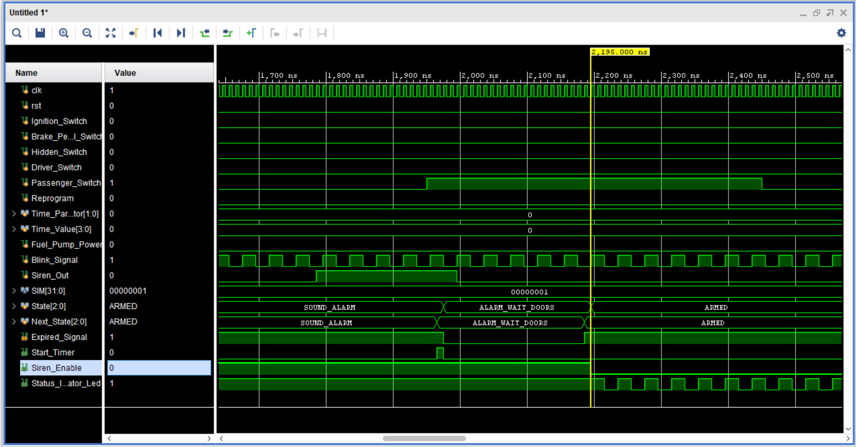

CONSOLE OUTPUT
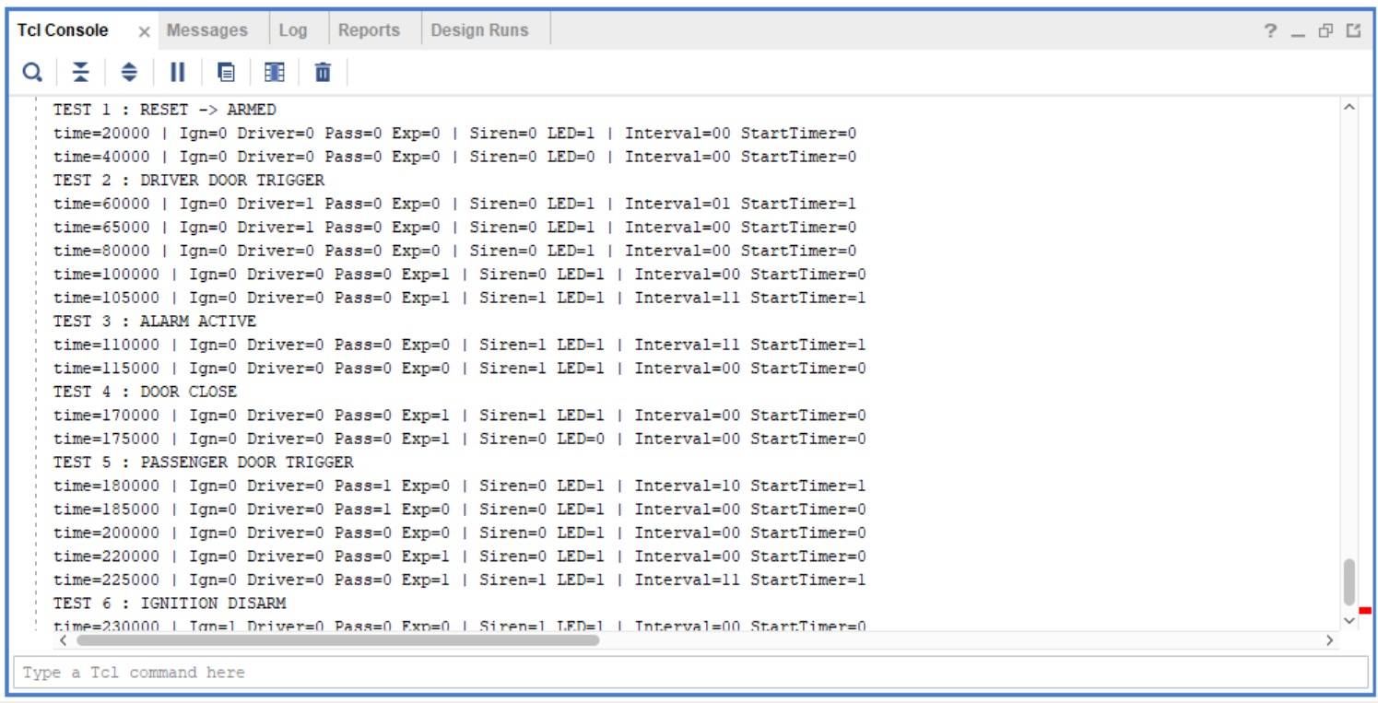

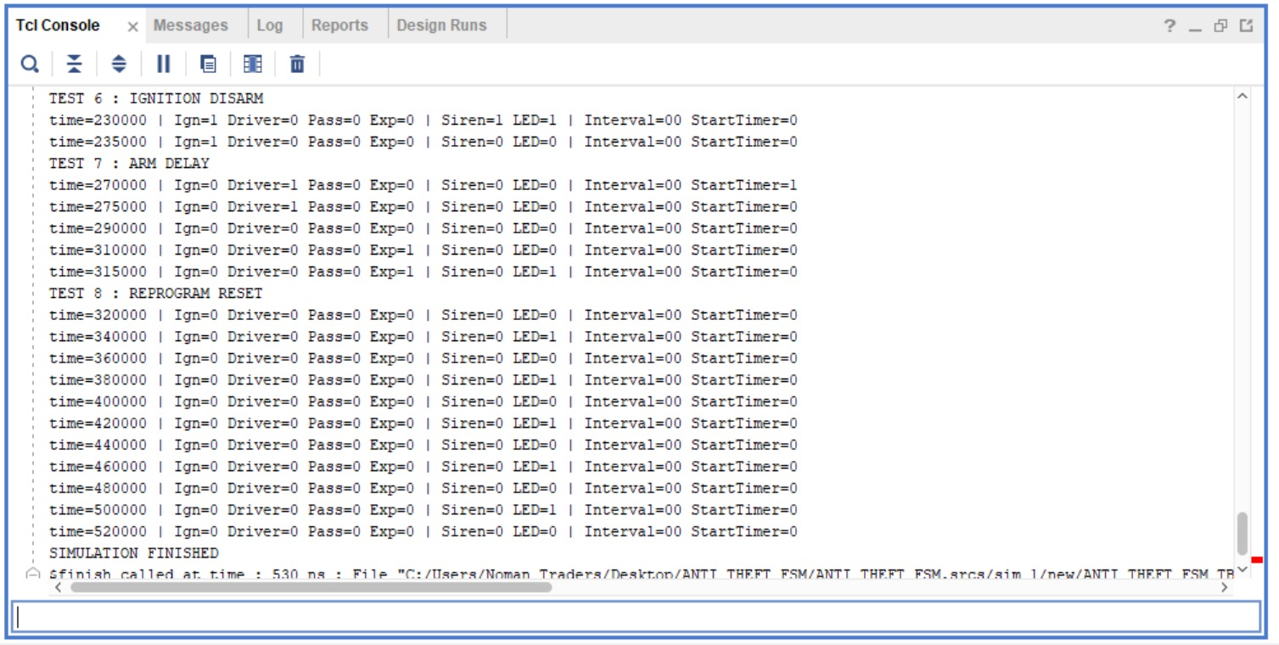
CONSOLE OUTPUT

1. What could happen if an input were not synchronized to the clock?

If an input signal is not synchronized with the system clock, it may cause metastability in the flip-flops. This occurs when an input changes very close to the clock edge, causing the output of the flip-flop to become unstable for a short period of time. As a result, the system may experience incorrect state transitions, unpredictable outputs, or timing violations. To prevent this issue, asynchronous inputs should be passed through synchronizers or debouncing circuits before being used by the FSM.

2. Describe your fuel pump and siren sound generator logic

Fuel Pump Logic:

The fuel pump is disabled when the ignition is OFF. When the ignition is turned ON, the fuel pump remains disabled until the driver presses both the hidden switch and the brake pedal simultaneously. Once this condition is met, the fuel pump power is enabled and remains latched ON until the ignition is turned OFF again.

Siren Generator Logic:
The siren generator produces a square wave signal used to drive the alarm speaker. It alternates between 440 Hz and 880 Hz frequencies using counters and clock division. This creates the typical alternating alarm sound when the siren is enabled.

3. Describe your divider module

The divider module converts the 100 MHz system clock into a lower frequency signal. A counter counts clock cycles until it reaches 100,000,000 cycles, which corresponds to one second. At that point, a 1 Hz enable signal is generated. This signal is used by the timer module to perform second-based countdown operations and to control LED blinking.

4. Describe the design flow for your system

The design process followed a structured approach:
- System Specification – Understanding the requirements of the anti-theft system.
- Module Partitioning – Dividing the system into modules such as FSM, Timer, Debouncer, Fuel Pump Logic, and Siren Generator.
- FSM Design – Creating the state transition diagram for system behavior.
- RTL Implementation – Writing SystemVerilog code for each module.
- Testbench Development – Verifying each module through simulation.
- System Integration – Connecting all modules in the top-level design and verifying the complete system functionality.

CONCLUSION:

- Learned how to design and implement a Finite State Machine (FSM) using SystemVerilog.
- Understood how a car anti-theft system works using sensors and control signals.
- Gained experience in modular digital design by implementing different system modules.
- Learned the importance of synchronization, debouncing, and timing control.
- Practiced RTL coding, simulation, and verification of a digital system.

